Quarterly Business Report

Contents

Business Overview 2

Customer Metrics 3

Distribution of Customers across States 3

Average Customer Rating by Quarter 3

Trend of customer satisfaction 4

Top vehicle makers preferred by customers 4

Most preferred vehicle in each state 5

Revenue Metrics 6

Trend of purchases by each quarter 6

Quarter on quarter % change in revenue 6

Trend of Revenue and Orders by Quarter 7

Shipping Metrics 7

Average discount offered by Credit Card type 7

Time taken to ship orders: 8

Insights and Recommendations 8

# Business Overview

**Total Customers**

994

**Total Orders**

1000

**Last Quarter Revenue**

15.18 M

**Total Revenue**

82.61 M

**% More than Good Feedback**

44.10

**Average Rating**

3.135

**Average days to ship**

97.9640

**Last Quarter Orders**

199

# Customer Metrics

## Distribution of Customers across States

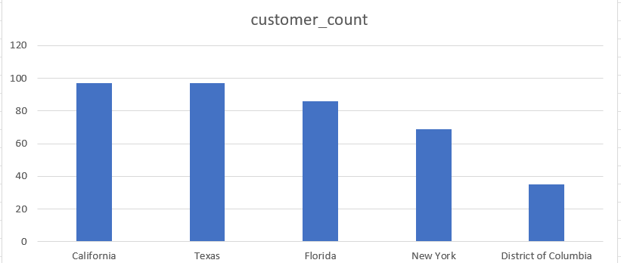

**Observations:**

* California and Texas have the highest customer population across all US.
* District of Columbia rated 5th highest customer population is just half of that of New York’s population. This means after New York, the customer population has dipped in half.

## Average Customer Rating by Quarter

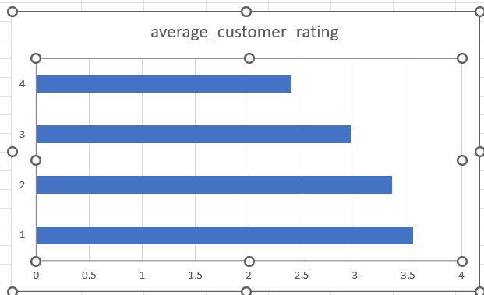

**Observations:**

Average customer rating has been dropping with each quarter. First quarter has recorded of 3.6 as highest rated which dipped to 2.4 in the final quarter.

## Trend of customer satisfaction

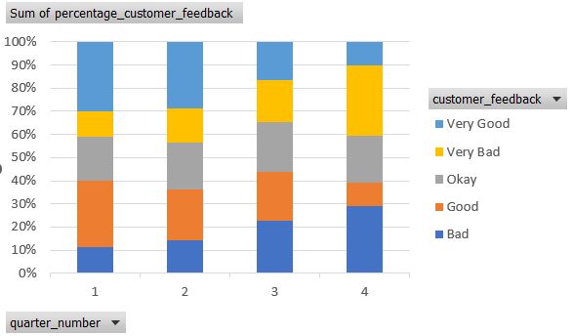

**Observations:**

* Customers providing bad rating has been increased with every quarter.
* There is only 10% of very good rating in the final quarter which is 20% lesser than the feedback got from first quarter. The services seem to be depreciating.

## Top vehicle makers preferred by customers

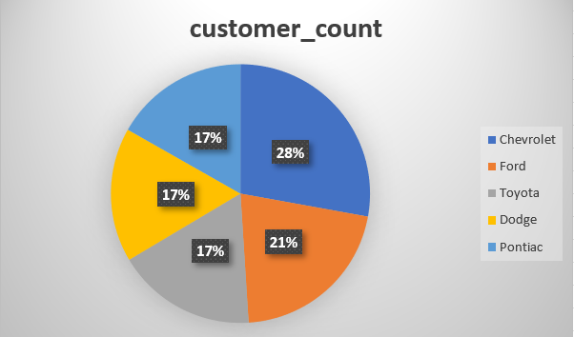

**Observations:**

* The most preferred vehicle being Chevrolet covering 28% of the total customer population.
* Toyota, Dodge and Pontiac are equally considered being 17% of each contribution to the total customer population.

## Most preferred vehicle in each state

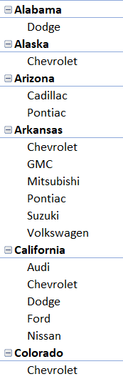 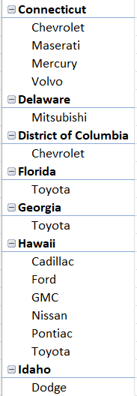 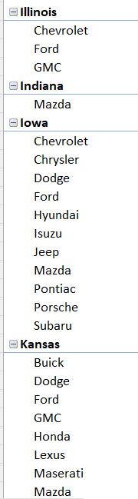 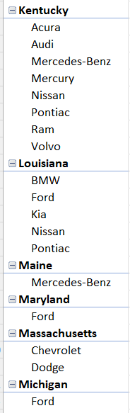

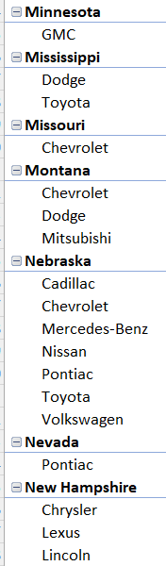 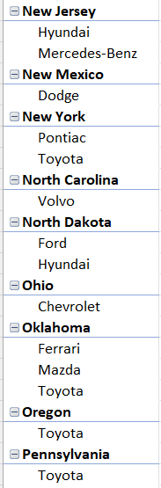 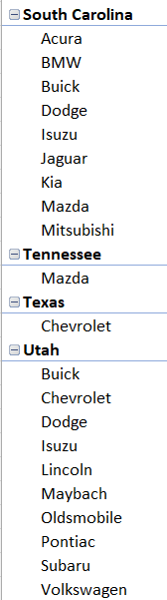 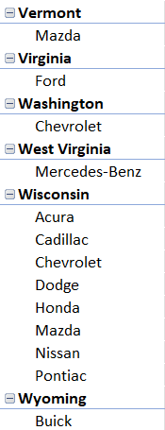

**Observations:**

* Dodge seems to be one of the make preferred alone in states like idaho alabama etc.
* Apart from the selected few, all states have more than one preferred car make of their own.

# Revenue Metrics

## Trend of purchases by each quarter

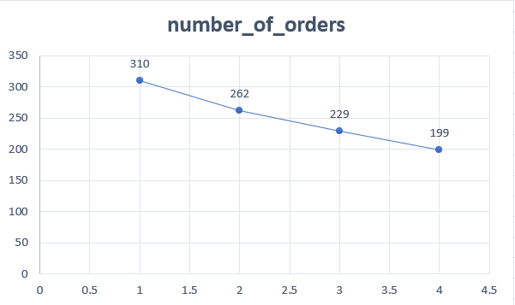

**Observations:**

There is a steady drop in purchases from each quarter going 310 in first quarter to 199 in the final quarter

## Quarter on quarter % change in revenue

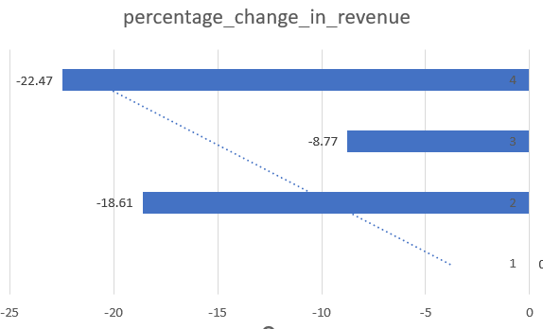

**Observations:**

* The revenue drop from quarter to quarter is so less in 2nd to 3rd alone marking around 8.7%.
* There is significant drop in revenue from each quarter considering from 1 through 4th quarter in sales.

## Trend of Revenue and Orders by Quarter

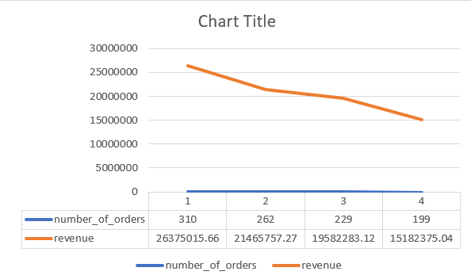

**Observations:**

* It is evident as the number of orders reduces from quarter to quarter, the revenue also reduces respectively.
* We can see a depreciating pattern in terms of revenue to orders to each quarter.

# Shipping Metrics

## Average discount offered by Credit Card type

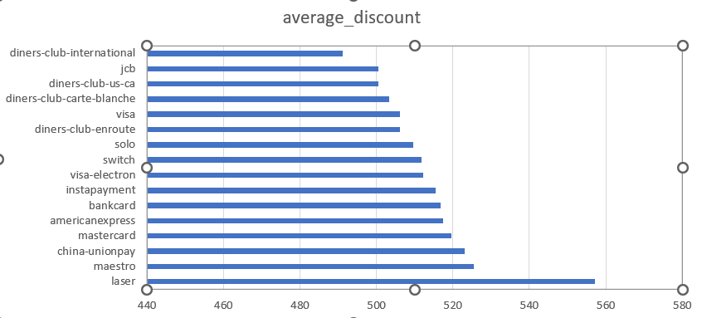

**Observations:**

* Laser credit card has offered the highest average discount on the whole marking $557.
* There is no significant difference in any other credit card companies offering nearing to the top one. The lowest marked is $490 by diners-club-international.

## Time taken to ship orders:

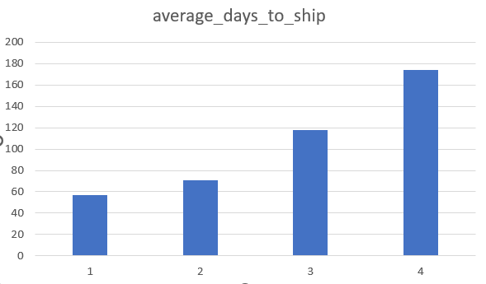

**Observations:**

* The time taken to ship orders in an average increase from one quarter to the other. This shows the delay in the responses of orders placed.
* The time taken to deliver in quarter 1 is 57 and in the quarter 4 is 174, almost tripled the response delay.

# 

# Insights and Recommendations

* The drop in customer review and customer satisfaction is the main cause of adverse impact of reduced sales and reduced revenue.
* The time taken to ship the cars has been increased quarter by quarter and this is affecting the delivery rate leading to affect the customer requests and satisfactions.
* Improving dynamic decisions like seeing through which car makes are popular in some states, understand the trend and make shipping early would increase the customer review which might add to increase the number of sales amounts.
* Finding combination of credit card discounts to its appropriate state and the preferred car would push the sales in positive direction. Customers might appreciate the combination offers given to them when needed.
* Follow up on the reviews once provided by the customer and get back to what went wrong? What could have been done to get much more standard review? And start building pivotal plans in order to improve the customer satisfactory ratings.
* Update the list of preferred car makes for each state from quarter to quarter and cross verify to negate the false positives to get much more efficient strategies to put into use.